Animations in CSS

Basic idea is to give property

Animation: <animation name> <time in millisec>

Than define that animation using

@keyframes <animatioName>{

0%{

Breakpoints

}

}

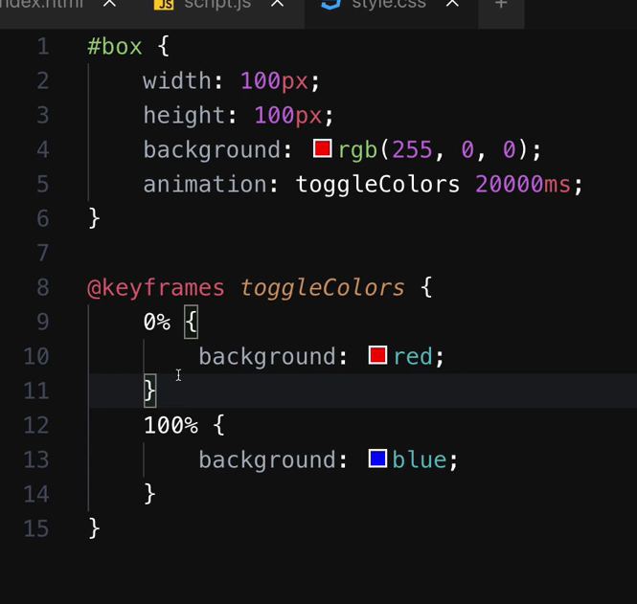

Linear means – no speed difference – Every time same speed

We can use more like ease-in/ease-out/

Go to console to make your own Bezier curve

Infinite – runs infinite times



Maintain final animation state 100%{ vale breakpoint } ki state

Use forwards



Also use it with no of iterations



Lets play with top and position

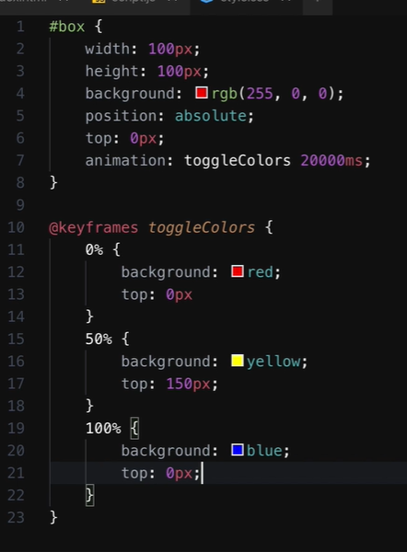

Combining 2 keyframes

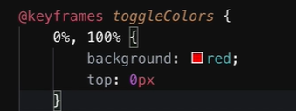

For an instant property change 